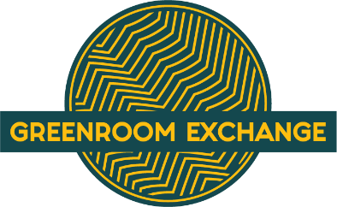
GREENROOM EXCHANGE
Offering Commission Grants for International Artists

FALL 2022

DESCRIPTION: GreenRoom Exchange has a fund to support international artists residing in Kentucky. In line with our mission statement, we are awarding commissions to artists whose work celebrates traditions beyond mainstream American. The grant is to be used to create new works in any category of music, dance or visual arts.

ELIGIBILITY: International musical, performing and visual artists who want to show case their country of origin through artistic expression are eligible to apply. (with the ability to receive funds - W-9 or Social Security Number) We ask for a willingness to cooperate with GreenRoom Exchange and participate with the community of Lexington, Kentucky to to showcase your work, virtually and/or in-person in the future. We ask that you identify a sponsoring community agency to facilitate this process, if needed.

AWARD PROCESS: A panel of GreenRoom Exchange Board members will review the submissions and conduct a brief interview with the artist (in person or via Zoom) to hear application details and answer the panel’s questions.

SUBMISSION DEADLINES:
Applications Due: July 22, 2022
Recipients Announced: August 19, 2022
Art Work Delivered: November 11, 2022

GRANT AWARD: Request $500.00 - $1,000.00. If awarded, half of the amount is given when the project is started, and the remainder is provided at the completion of the project.

For questions please contact: Connie Milligan connie@greenroomexchange.org 859-806-8910 or Lee Carroll lee@greenroomexchange.org.

GreenRoom Exchange Mission Statement: GreenRoom Exchange creates international cross-cultural experiences, bringing artists and musicians from other countries to work with local artists, expanding our understanding of their cultures, enriching our community. For more information go to www.greenroomexhange.org

INTERNATIONAL ARTIST GRANT APPLICATION

Please fill out the following details:

NAME:
__________________________________________________________________________________
ADDRESS:
__________________________________________________________________________________
DATE OF BIRTH: PHONE NUMBER:
__________________________________________________________________________________
EMAIL ADDRESS: COUNTRY OF ORIGIN:

SUBMISSION DETAILS:

- A brief statement about your work and how it highlights your country of origin. (200 words or less)

- A brief proposal about the your work for this grant. (200 words or less)

- A brief biography (or attach a resume)

- Please provide 2 - 4 examples of your work. Photos, videos, or audios required – Please upload your jpg, MP3, mp4, with the application submission. Any additional details or links to YouTube videos, social media sites or website can be placed here:

- Grant amount request ($500-$800) $____________________
Please briefly explain how the grant money will be used.

ARTIST SIGNATURE:___________________________________________________Date:__________________
(Electronic signature is OK if unable to print and scan – your signature indicates you agree to these terms and are willing to have your work showcased.
SPONSOR ORGANIZATION _______________________________________________________________
NAME OF CONTACT PERSON_____________________________________________________________
PHONE #___________________________________EMAIL _____________________________________

_____ Please check if you do not need a Sponsor Organization to help you connect with Zoom for the interview or with submitting your application.

